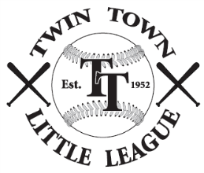
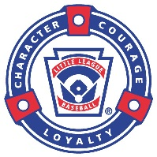
Twin Town Little League
Full and Partial Scholarship Request Form

Twin Town Little League (TTLL) will not deny any child a chance to play baseball due to financial hardship. Full or partial scholarships are available. Please complete and return this form and the required information by email (twintownlittleleague@gmail.com) or mail the form to: Twin Town Little League, PO Box 369, West Sand Lake, NY 12196.

SCHOLARSHIP ELIGIBILITY REQUIREMENTS
To be eligible for a full or partial scholarship, you must:

- Register the player(s) for the upcoming season. This may be done on-line or in-person
- Provide proof of residency and age (Not required for returning players)
- Provide a copy of an approved Free or Reduced Price Schools Meals Application by the local school
- Provide a brief explanation in the space provided below of why you should qualify for a full or partial scholarship. If requesting a partial scholarship, please include how much you are willing to pay. If you are requesting a payment installment plan, please provide details on when payments would be made.

Parent or Legal Guardian Name | Player(s) Name | Level (Tball, Farm, Minors…)

Home Address | City | State | Zip

Daytime Phone | Evening Phone | Mobile Phone | Email Address

Financial Hardship Explanation

I, as the Parent or Legal Guardian of the player(s) named above, attest to the truth for the above information to the best of my knowledge.

__________________________________ _______________________
Parent or Legal Guardian Signature Date

FOR TTLL USE ONLY

Date Reviewed:
☐ Full Scholarship Granted | ☐ Partial Scholarship Granted | ☐ Request Denied
Amount: $ | Amount: $

